KARDAN JOURNAL OF ECONOMICS AND MANAGEMENT SCIENCES (KJEMS)
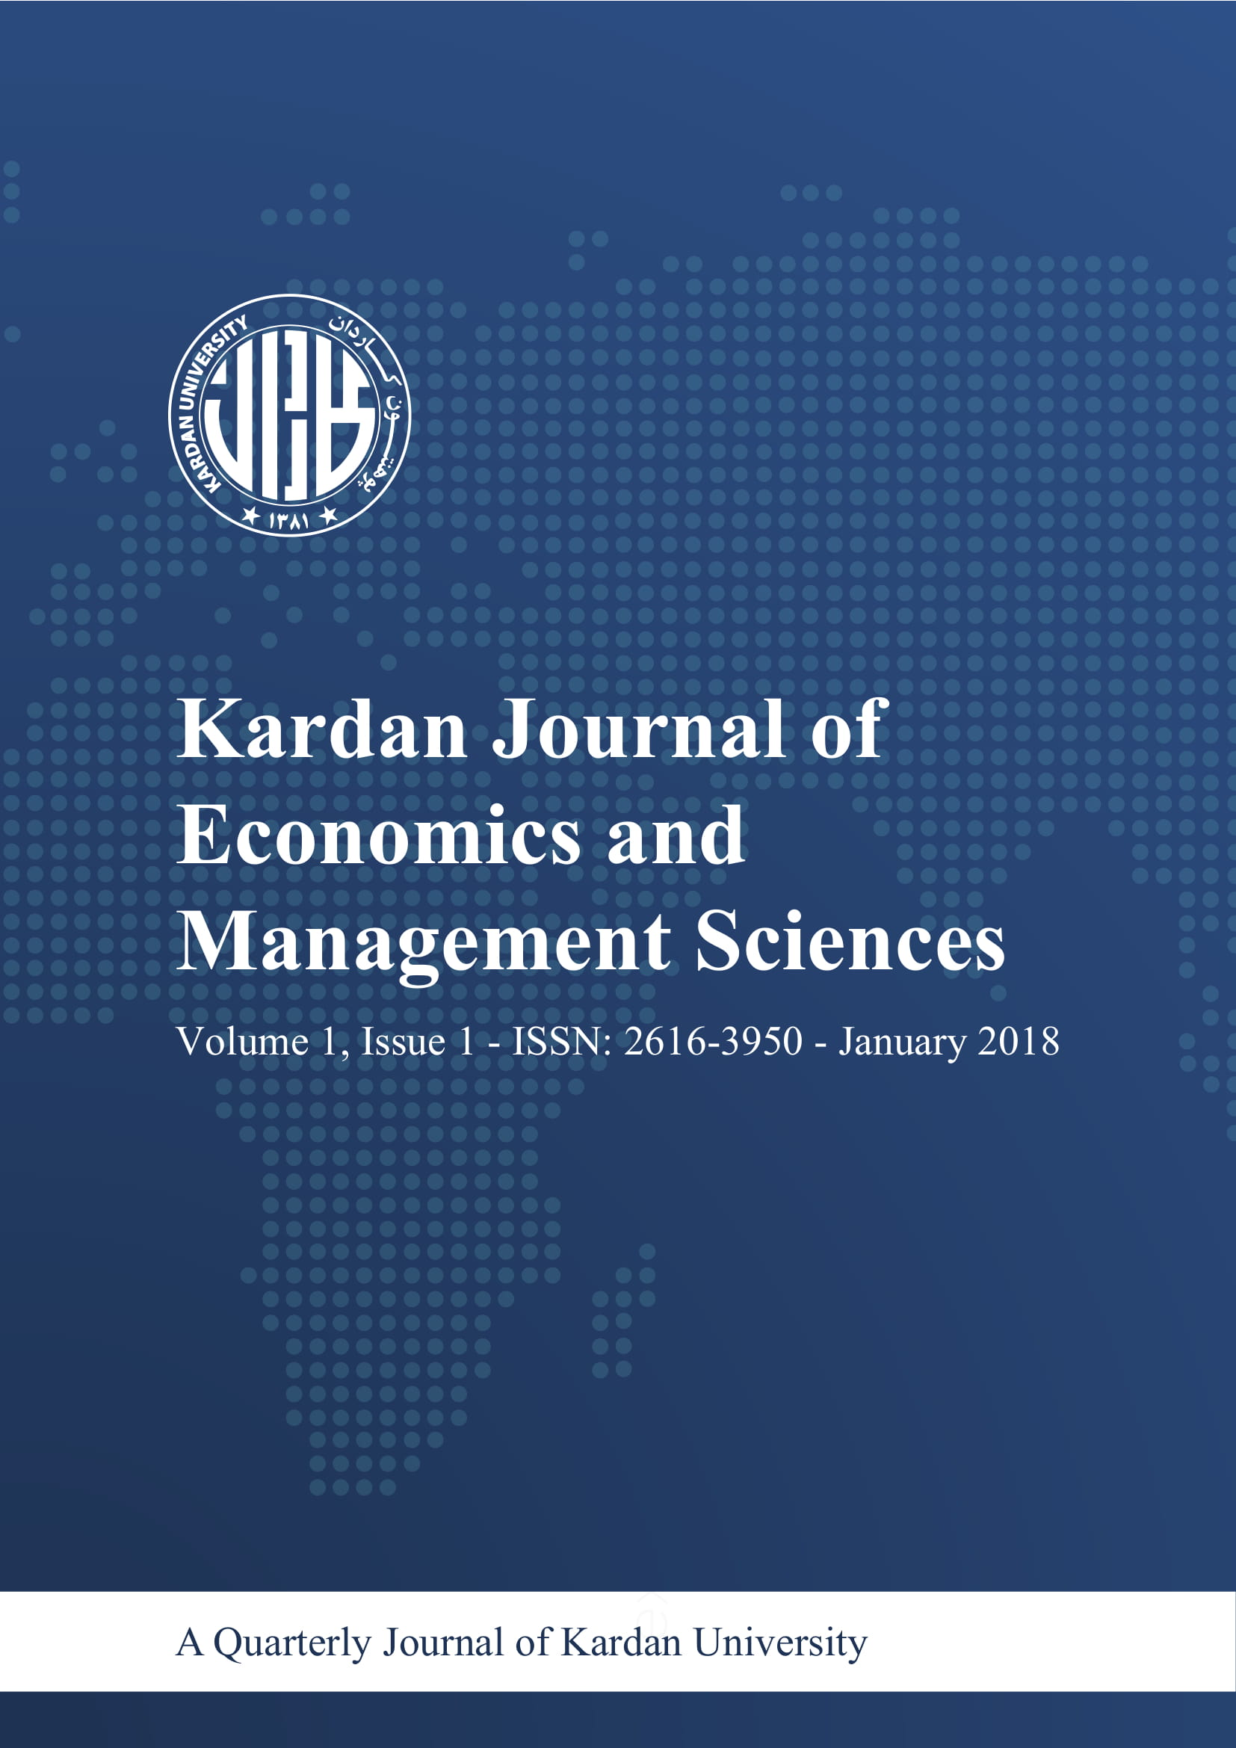
ISSN: 2616-3950

Author(s) Declaration Form
(Authorization on Organization’s Letterhead)

To be filled by authors:
Title of Paper: ______________________________________________________________________________________________________
Focus Area / Theme for the paper:

First Author  Name  Designation  Organization  Address  Phone No  Mobile No  ORCID:  E-mail | Second Author  Name  Designation  Organization  Address  Phone No  Mobile No  ORCID:  E-mail

Declarations:
The Paper submitted has been developed by me/us, is original, unpublished and I/we alone are responsible for the correctness of events, information and data cited. We agree to transfer the copyrights to Kardan University, Kabul, Afghanistan.
(First author) (Second author) (Third author) (Fourth Author)

Please send the filled-up form to:

Dr. Nassir Ul Haq Wani
Chief Editor, Kardan Journal of Economics and Management Sciences
Head, Department of Research and Development
Parwane- Du Square
Kardan University, Kabul, Afganistan
E-mail: editorkjems@kardan.edu.af.or n.wani@kardan.edu.af

